**Create and Deploy pod Definitions**

**Step 1 : Create a yaml file**

# vim python1.yaml

apiVersion: v1

kind: Pod

metadata:

name: python1

spec:

containers:

- name: python1

image: anilbidari/python:v1

ports:

- containerPort: 5000

**Step 2 : Create a pod (nginx.yaml)**

# kubectl create -f python1.yaml

**step 3 : Login to container**

kubectl exec -it python1 /bin/bash

ls -la

exit

**step 4 : copy a file**

touch anil.txt

kubectl cp anil.txt python1:/tmp/

kubectl exec -it python1 ls /tmp

**Step 5 :List the pods**

# kubectl get pods

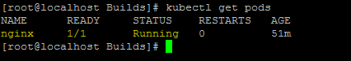

**POD > containers**

**Validate where your container is running**

kubectl describe pods python1

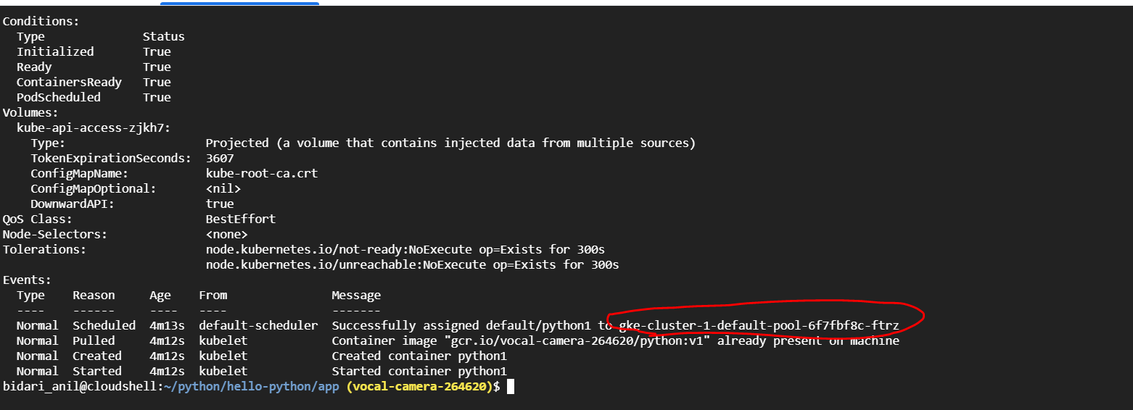

**Step 6 :Delete the nginx pod ( master node)**

# kubectl delete pod python1

**=========================completion of lab ==================================**